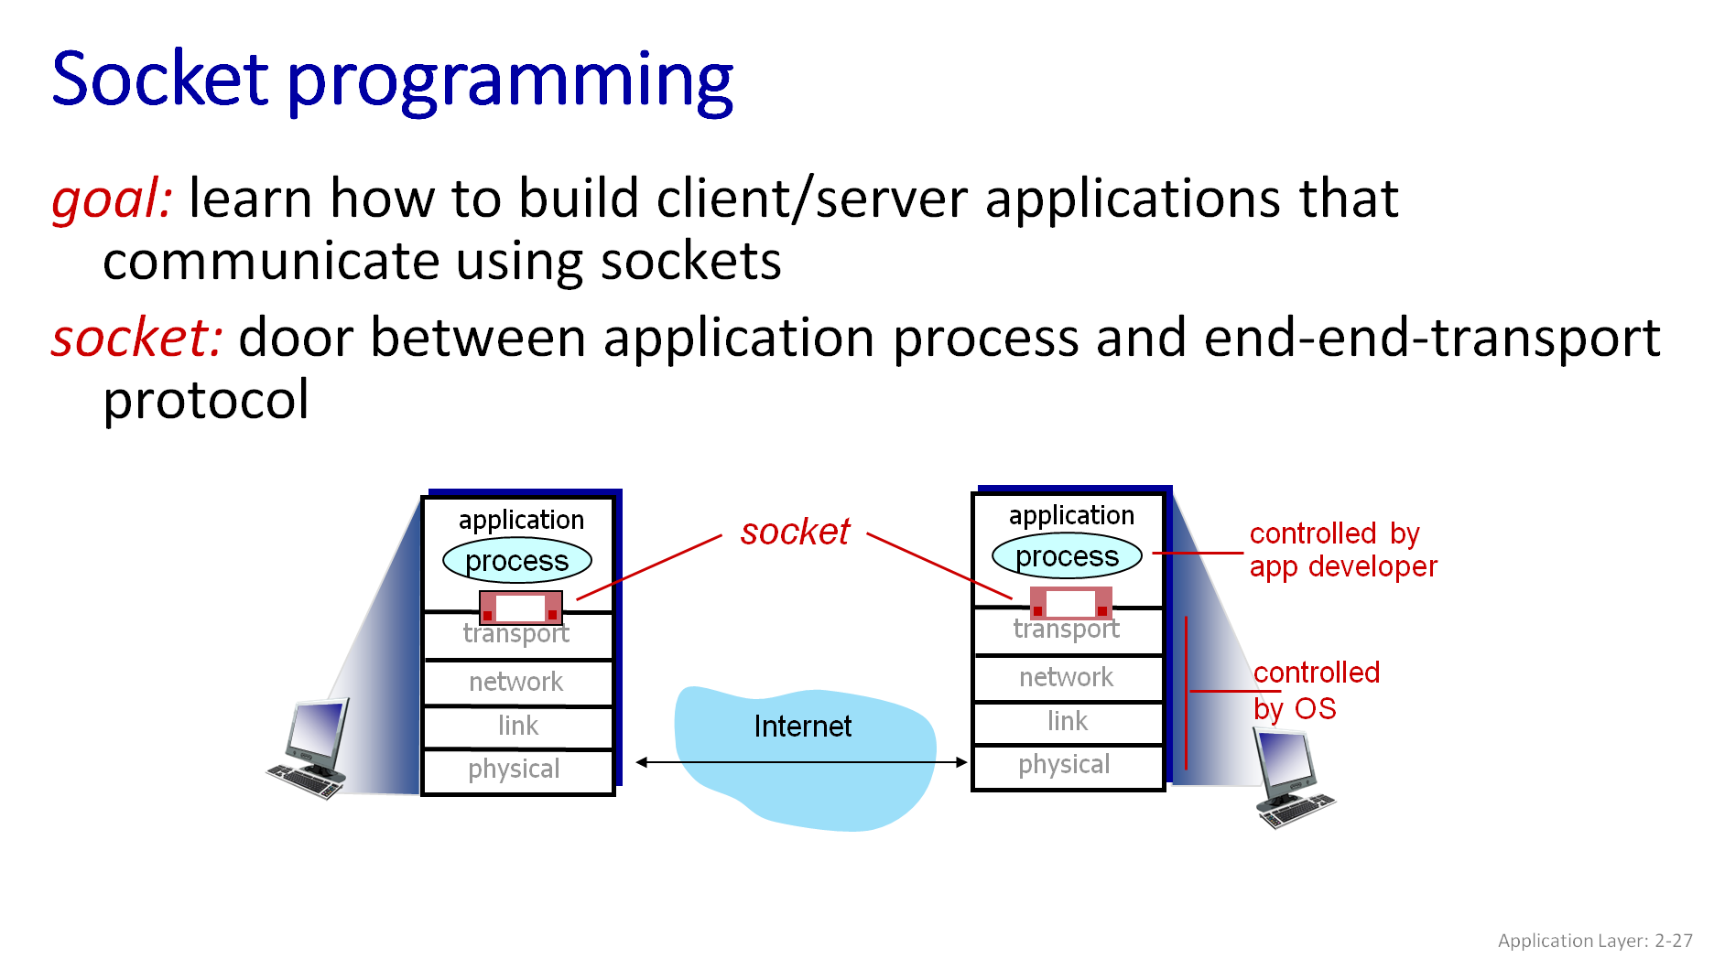
Two socket types for two transport services:
- UDP: unreliable datagram
- TCP: reliable, byte stream-oriented
UDP: no “connection” between client and server:
- no handshaking before sending data
- sender explicitly attaches IP destination address and port # to each packet
- receiver extracts sender IP address and port# from received packet

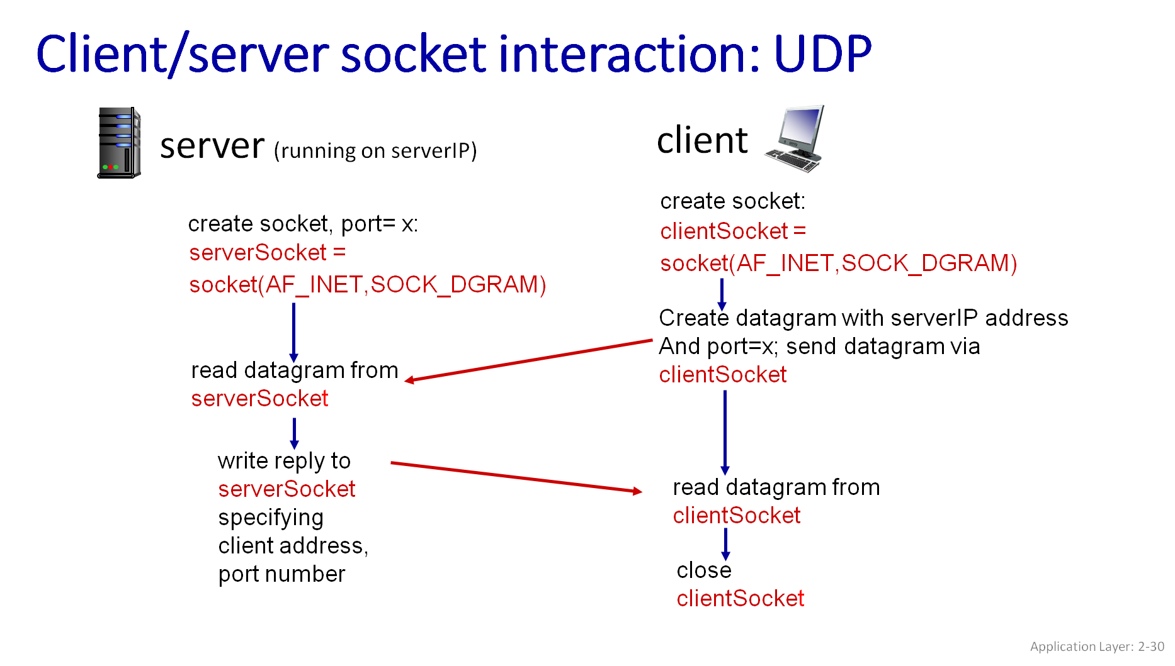
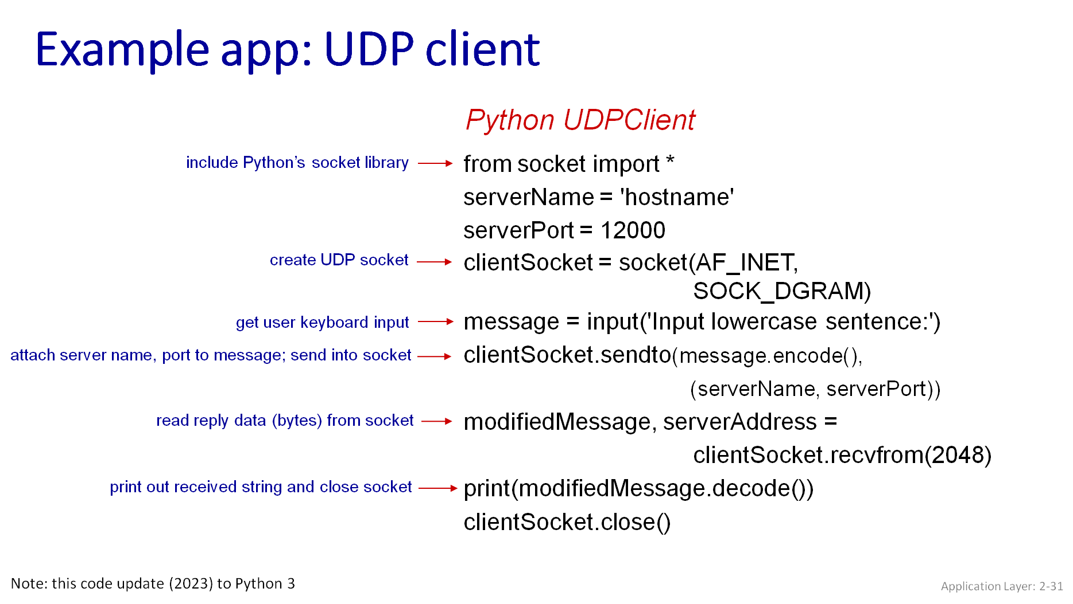
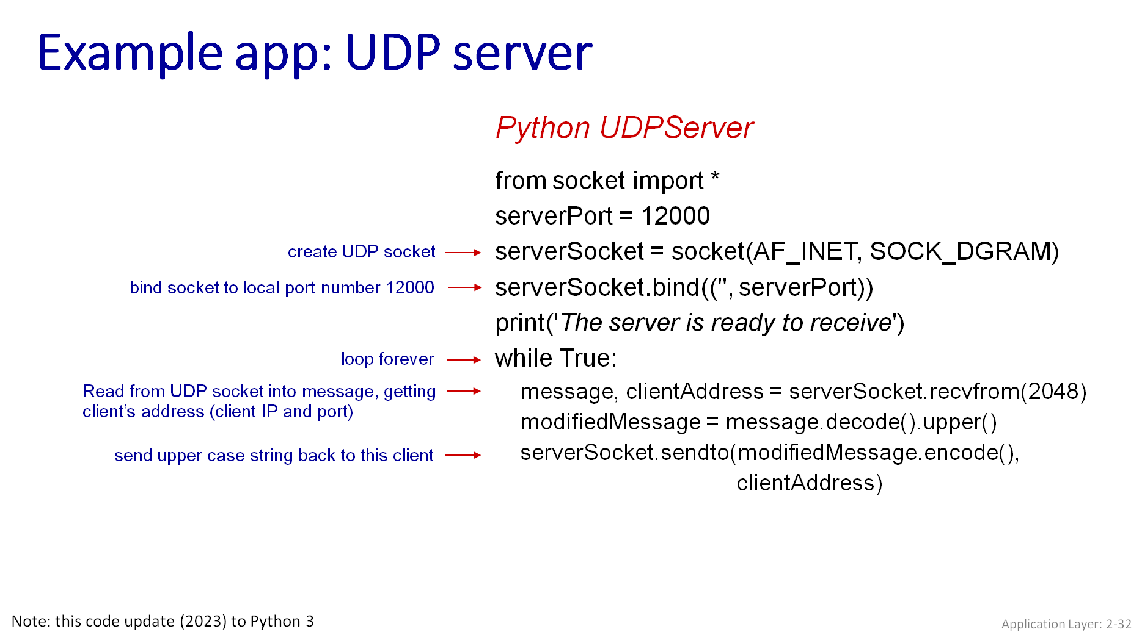

Syntax to use ns3:

All code files must be in specific folder to be executed, write following commands:
- Cd ns3-allinone-
- Cd ns-3.x
- Cd scratch
- Touch file.py
Run command:
- ./ns3 run file.py
Libraries:
- import ns.applications
- import ns.core
- import ns.internet
- import ns.network
- import ns.point_to_point
- From socket import *

Output:

